**Development and Evaluation of four Mixed Reality Educational Applications**

# Abstract

As the Chinese ancients saying goes for education: "读万卷书，行万里路", "Travel ten thousand miles is as important as to read ten thousand books. " One who wants to be successful, study only is not enough, study is wisdom, travel is experience, experiences can transform into wisdom. It may even be more practical and important than the wisdom gained from the book directly. However, if one has not enough knowledges gained by books, experience is only experience can’t be transform into wisdom. The wisdom of the ancients warned us that in education, knowledge and experience are mutually reinforcing and indispensable. However, the reality is that because of the implementation conditions, the education we receive focuses on the reading of books, and the lack of sensory and intuitive stimuli to enable us to experience and understand the knowledge we have learned. Immersive experience is very important in education. However, under the traditional education mode, because of the limitation of time and space, it can’t provide sufficient experience environment for students. Such experience in the actual implementation of teaching is very inconvenient. However, with the rapid development of computer technology, the reality of computer simulation can replace “Travel ten thousand miles” and help us to make up for the vacancy. For example, when it comes to geography, with the use of devices the students are brought into the local terrain where there is the terrain is being learning. When it comes to biology, it is substituted into the local plant and animal life Environment, in the Chemistry class students can experience directly with chemistry, etc. And more importantly, these implementations are not limited by space and time. with the support of devices, learners can experience anywhere and anytime These technologies have brought a revolution to traditional education and brought untold potential to development.

A new era of education is approaching, allowing students to move from a passive acceptance process to an autonomous learning process. This will be driven by virtual reality and UGC (user generated content) [1]. We are just beginning to see developers making huge breakthroughs in imaginative educational content for children and adolescents. Virtual Reality is a simulation technology that emphasizes the hands-on experience and engagement of user simulation. At present, there are many applications of virtual reality in many fields. The combination of virtual reality technology and experimental teaching is analyzed and the advantages compared with the traditional teaching mode are expounded. The basic principles of application design and interaction design are introduced, and the immersion of virtual experiment is enhanced for the application of virtual reality technology and augmented reality technology Feelings and improve teaching have provided a viable approach.

This thesis designed and developed four AR / VR education application implementation cases, they are respectively 1, AR Ludo game; 2 VR art exhibition; 3, AR 3d Coloring game; 4, MR Chemistry Lab and introduced each application design Finally, through the actual experience of these applications, we analyze the implementation results respectively in educational effect, user experience and equipment, and get some experiences and methods of AR / VR education application design and development in some educational applications . That is, in the design and development of educational applications, the following principles should be followed ：. .

Keywords: Virtual & Augmented Reality; Educational Application; Experiential & Interactive Learning, Game-based Learning

**Contents**

Abstract

1. Introduction

1.1 Concepts

* VR
* AR
* MR
* Distinguish and apply fields of VR，AR and MR

1.2 Objectives and Scope

1.3 Contribution

1.4 Dissertation structure

2. VR and AR Background

2.1 researches

2.2 Educational Applications Typical types and Examples

2.3 Interaction Design

2.3.1 the development of human- centered Interaction Design

2.3.2 Interaction Design for VR and AR

2.3.3 User Interface Design for VR and AR

2.4 Summary

3. A Ludo game

3.1 Implementation Methods

3.2 Game Design

3.3 Project Implementation

3.4 Conclusion

4. VR Art exhibition

4.1 Implementation Methods

4.2 Game Design

4.3 Project Implementation

4.4 Conclusion

5. AR 3D Coloring Game

5.1 Implementation / Related Methods

5.2 Game Design

5.3 Project Implementation

5.4 Conclusion

6. MR Chemistry Lab

6.1 Implementation / Related Methods

6.2 Game Design

6.3 Project Implementation

6.4 Conclusion

7. Evaluation

7.1 Evaluation system

7.2 Evaluations for the 4 cases

7.3 Evaluation Result

7.4 Summary

8. Conclusions

8.1 Review of Objectives

8.2 Discussions

8.2.1 Limitations

8.3 Recommendations for future work

List of Figures

List of Table

# **Ⅰ Introduction**

This chapter presents a brief overview of the context under which the research was conducted. Background information regarding this study is provided in order to establish research objectives and scope. Then, the contributions are discussed. Finally, the structure of the dissertation is outlined.

* 1. Concepts

Virtual Reality (VR) and Augmented Reality (AR) techniques were proposed as early as the 1960s. Earlier, they have been classified as the development phase of cutting-edge science. Mixed-reality (MR) is based on the development of AR and VR proposed by Ronald Azuma, both VR, AR and MR are human-computer interaction between the virtual environment generated by the human-computer interface, application development prospects are very broad.

1.1.1 Virtual Reality

Virtual Reality Immerses a user in an imagined or replicated world (like video games, movies, or flight simulation) or simulates presence in the real world (like watching a sporting event live). Example of hardware players in VR are Oculus, Sony PlayStation and Samsung Gear VR [24].

VR systems are divided into three types: VR HMD + PC; VR HMD + Mobile and VR all in one. VR HMD + PC representatives are: Oculus Rift, HTC Vive Fig.1 (a) HTC introduced Vive Pro and Vive wireless adapter. Lenovo introduced Mirage Solo. HMD + Mobile is represented by the Samsung Gear VR and in June 2014, at the Google I / O conference released Cardboard glasses box Fig.1 (b), in general, the glasses box is the phone into the VR case in watching VR display device. Although relatively rough experience, but such devices do not require complex electronic components, lower cost, and mobility and portability. VR all in one machine as shown in Fig.1 (c) need to display, computing, storage, power and other functional modules are fully integrated into the headset display device. If you want to achieve good performance, the display device is difficult to be compact. 2017 Millet and Oculus jointly launched the VR Miracle VR machine, PS VR relies on the PS4.

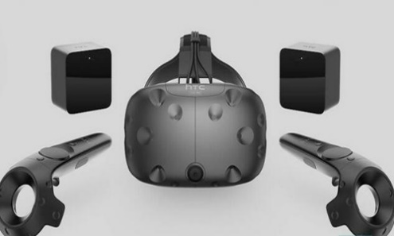 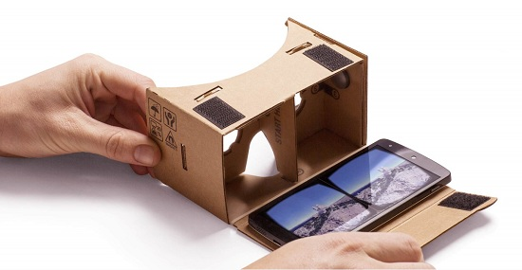 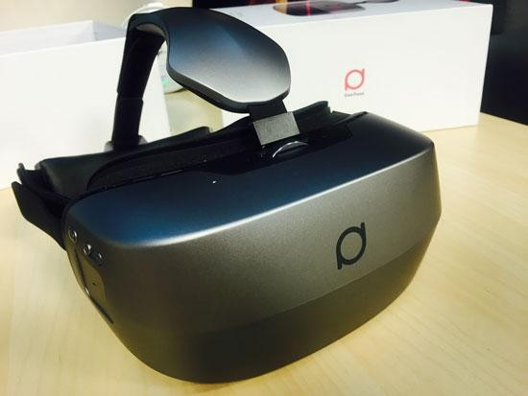

（a） (b) (c)

Fig.1 3 Kinds of VR devices

The core technologies of VR are tracking and CG (computer graphics). In the latest technology of VR, the Google Tilt brush that won the Cannes International Creative Festival digital process awards can be represented. Tilt brush is Google's VR drawing software, using HTC VIVE's HMD and control handles, which can make you in 3D Create paintings in space! Artists use digital technology to create in the three-dimensional world, not just the 2D plane. This will certainly affect the creation of the entire art field. This means that in the future you may be able to enjoy a painting as if you were admiring a building. As shown in Fig. (a) you can draw a volcano. It is envisaged that this technology will be used in the field of education. To give a small example, the math teacher in high school will do everything we can to help us understand that the graphic he draws on a flat blackboard is a solid figure, not a flat figure. Draw a solid directly in the three-dimensional world. As shown in Fig. 2(b), the process will be intuitive.

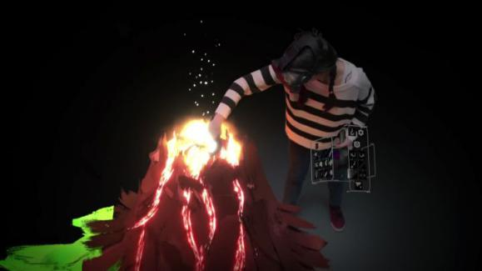 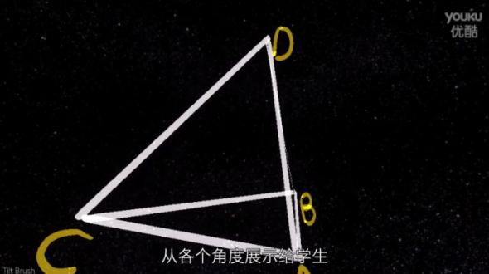

（a） (b)

Fig.2 Google Tilt brush and Math application

Similarly, World Brush lets you draw 3D shapes and designs in the real world. It's very similar to Google's Tilt Brush VR application. The cool part is that no matter what you draw, it stays there (or until you delete it), and you can smear it with an application brush around it, as a sticker or art painting. Each painting is anonymous and saved at the GPS location created. To make users more searchable, World Brush uses a scoring algorithm that combines popularity and creative time to provide the best content based on your location. So you can draw something and share online, other people can see and appreciate your work on the phone. Since World Brush is integrated with the real world and belongs to the definition of AR, we look at the application of AR below.

 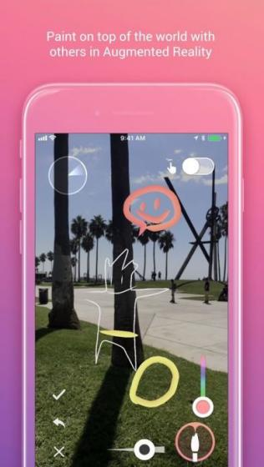

Fig.3 World Brush

1.1.2 Augmented Reality

“Augmented” means improved or expanded or enhanced. Example of a general Augmented reality might be the ability to wear headphones that can allow you to hear sounds (higher or lower that the normal auditory spectrum) [7]. Augmented Reality overlays digital imagery onto the real world, Example of Hardware players on AR are Microsoft Hololens, Google Glass [24].

January 2015 Google launched Google Glass, 2016 Nintendo mobile AR game Pokmon Go swept the world, as shown in Fig.4, The user through the mobile phone camera in the real world to collect virtual animation characters. Augmented reality has also begun to open to ordinary users. In entertainment, AR camera application - FaceU, users can superimpose a variety of cartoon in their own photos in real time. On the military side, the concept of AR was first applied militarily and was first proposed by Thomas Caudell and David Mizell [27]. Its military application is also an important motivation for augmented reality. With AR technology, pilots can not bow their heads Look at the meter, you can read the HUD head-up display head-up display of the various states of the aircraft, such as heading, speed, fire control radar to provide enemy information. Similarly parking assist systems provide the system with the ability to proactively provide and make available information based on the current state of the vehicle (reverse gear) and relative position with surrounding obstacles without the user providing any additional information or instructions. Fig.2. At this year's CES showroom floor, we saw Skully AR smart helmet, Civil Maps vehicle AR platform, and WayRay [25], which offers a solution for a car head-up display (HUD). Google Translate app uses the camera that comes with your phone to translate textual information in a portion of the real world into another language, Fig.5.

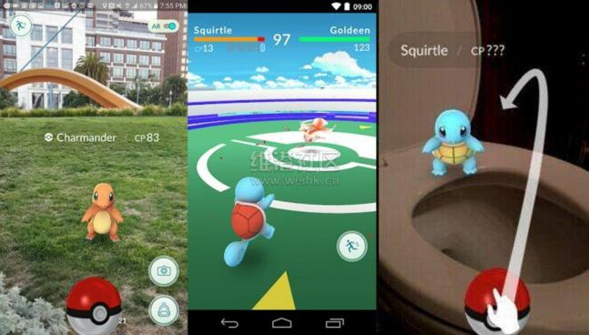

Fig. 4 [Pokemon Go Scenes【12】](http://link.zhihu.com/?target=https%3A//media.nngroup.com/media/editor/2016/09/18/pokemon-go-ar.jpg)

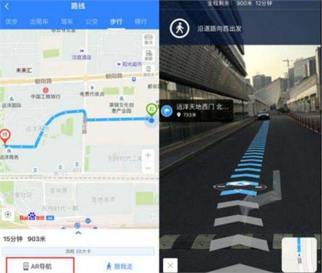

Fig.5 The AR navigation system [30]

As another example, IKEA has a new application that helps you to truly see how each piece of IKEA products is placed in your own home or office through augmented reality (AR) technology. The app currently has more than 2000 IKEA product options.

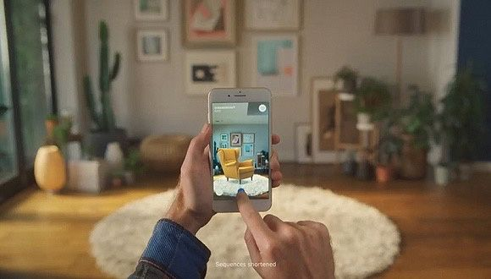 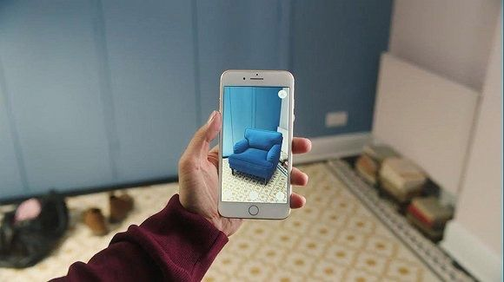

Fig.6 IKEA Place APP

In the latest AR applications, the vast majority of measurement applications on the shelves. The Measure Kit is different and more feature-rich. It can provide us with different functions and measurement methods. The application provides a track mode that allows the user to draw and measure trajectories. It can also be used to measure angles, person heights, build cube models, and more.

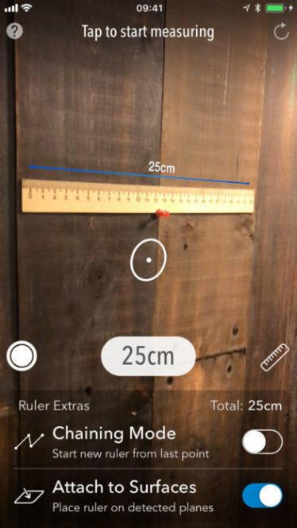 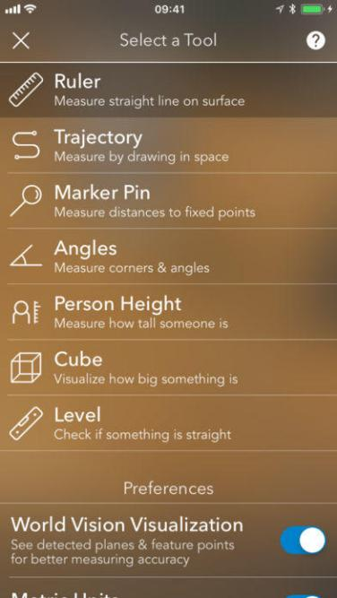

Fig. 7 AR MeasureKit Application

User experience AR applications, as long as the use of mobile phones (or with RGB camera PC) can be achieved, the principle is based on Marker identification and tracking, or can also be achieved through the SLAM technology. Marker can be 2D QR Code: The main function of the QR code is to provide a stable and fast identification. In AR, in addition to identification, the QR code also serves as a part-time function that provides easy tracking and positioning of the plane. For this reason, the two-dimensional code in the AR is simpler than the normal two-dimensional code in order to facilitate accurate positioning. Marker can be 2D Flat picture: Because the two-dimensional code itself is a two-dimensional image, the two-dimensional code method can be used directly on the two-dimensional image. Use two-dimensional pictures, such as banknotes, book posters, photo cards and more. The reason why the QR code is simple is that the design above it is designed so that the visual algorithm can quickly identify and locate. The general two-dimensional image does not have this good nature and needs a more powerful algorithm. And, not all 2D images can be used for AR positioning. For example, a solid image without any pattern can not be visually located. Marker can be a 3D Object: A natural extension of a two-dimensional image is a three-dimensional object. Some simple rules of three-dimensional objects, such as cylindrical cans, can also be used as a combination of the actual vector. Slightly more complex three-dimensional objects can often be handled in similar ways or decomposed into simple objects, as is the case in industrial repair. However, for some specific irregular objects, such as faces, many algorithms have been able to perform real-time accurate alignment due to years of research accumulation and massive data support. However, how to deal with common objects is still a huge challenge. Finally, the latest Marker focused on 3D Envionment: AR technology now focuses on the understanding and recognition of three-dimensional space and even interaction. Hololens is a bit more advanced, with the ability to repaint the entire real world with its own sensors and then superimpose digital content. But also can be aware of the current location of the device in space (depth information). Its optical display scheme has also become a waveguide, the lens thinner.

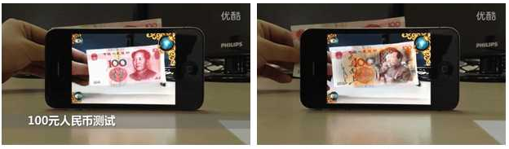

1. (b) (c)

Fig.8.QR Code and AR Application using Flat picture

Among the above-mentioned technologies, the identification and tracking technologies of two-dimensional code and two-dimensional images have basically been mature and have been widely used. The technical development goals are mainly to further improve the stability and broaden the scope of application. In contrast, there is still a lot of room for exploration in the identification of three-dimensional objects and three-dimensional environments. At WWDC 2017, Apple brought AR Kit, a new Augmented Reality component for iOS 11 that works on iPhone and iPad platforms. AR Kit, Apple's augmented reality (AR) technology, delivers immersive, engaging experiences that seamlessly blend virtual objects with the real world. In AR apps, the device's camera presents a live, onscreen view of the physical world. Three-dimensional virtual objects are superimposed over this view, creating the illusion that they actually exist. The user can reorient their device to explore the objects from different angles and, if appropriate for the experience, interact with objects using gestures and movement [26]. The upper part of iPhone X has a sensor that projects human invisible light to read the user's face 3D structure and instantly manipulate the data through the Apple Nerve engine to create a face model. This feature implements Face ID and cute Animoji show in Fig.8. The AR Kit uses the Visually Inertial Odometer (VIO) to track the surrounding environment with high accuracy and sense its movement within the room. For example, this application called AR ruler helps you to measure the precise size of an object without using any measurement tool. The AR Kit detects horizontal surfaces such as tables and floors, and tracks and places items at specific points. The AR Kit also uses camera sensors to estimate the amount of light available in the scene to apply the correct brightness to the virtual object. Google also introduced Google Tango before it launched AR core in 2017. AR Core based on the original Tango made many improvements, such as real-time light rendering, the virtual object in reality looks more natural and true.

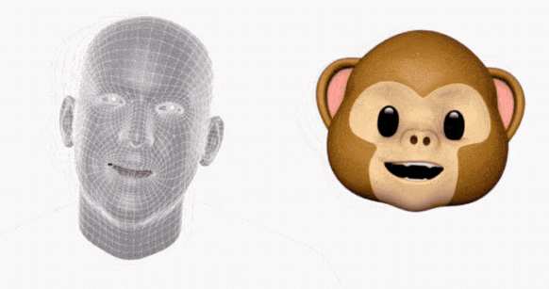

Fig 9. iPhone X to include animoji, emojis animated based on your facial expressions [31]

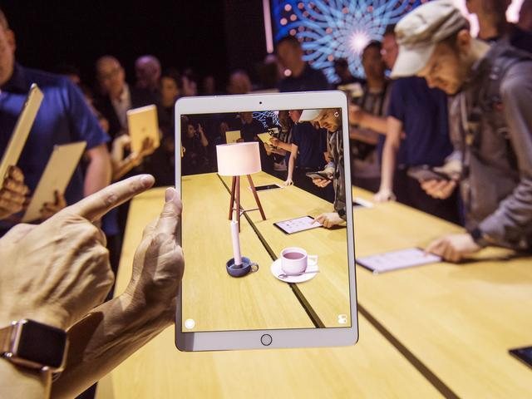

Fig.10 Apple AR light projection

1.1.2 Mixed Reality

There are two explanations about MR: Mixed Reality and Mediated Reality.

Mixed Reality : also known as naked eye reality + virtual screen, on behalf of the 2015 Microsoft released AR Hollerns AR equipment and Magic Leap in 2015, is the virtual environment projected into the real environment.

Mediated Reality: Digital reality + virtual digital picture. Mediated Reality is an older tradition, introduced by Stratton before more than 100 years ago, and he presented two important ideas: constructing special eyeglasses to modify how he saw onto the world, ecologically motivated admission to conducting his experiments within the domain of his everyday personal life [8].

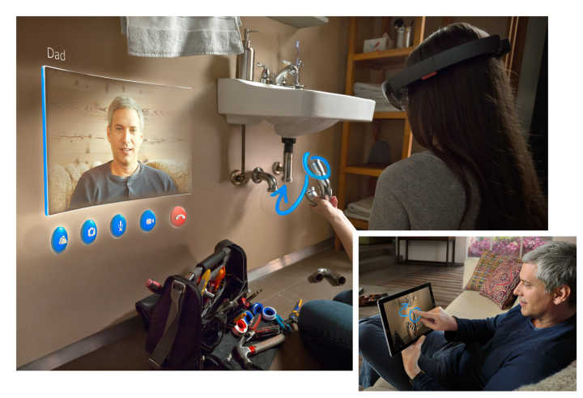

Fig.11 [HoloLens by MicroSoft](http://link.zhihu.com/?target=https%3A//media.nngroup.com/media/editor/2016/09/18/hololens.jpg)

Professor Ronald Azuma [3] at the University of North Carolina University summarized the augmented reality into three parts: virtual-reality integration, real-time interaction and three-dimensional registration. Paul Milgram and Fumio Kishino proposed the reality-virtual reality continuum, And the virtual environment as the two ends of the continuum, and the middle of them is called the "mixed reality" (Fig.11). Which is close to the real environment is to augment reality, close to the virtual environment is to expand the virtual environment.

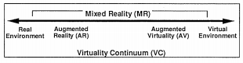

Fig.11 Simplified representation of a “ virtuality continuum.”

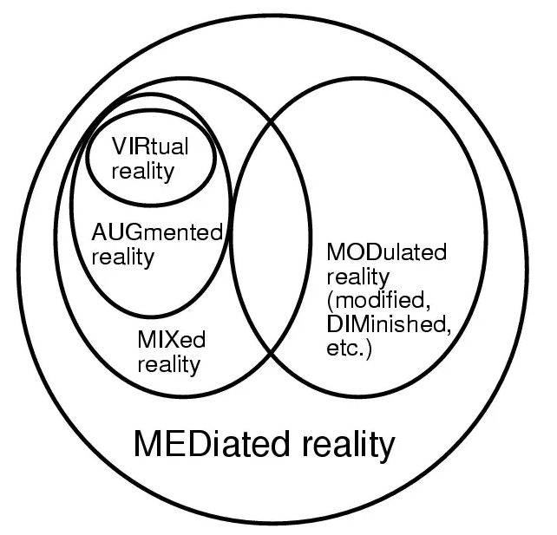

Fig.12 Venn diagram of the focus of the work

1.1.4 Distinguish and apply fields of VR，AR and MR

Virtual reality, augmented reality and mixed reality, there are differences between the three technologies to achieve, simply put: VR put the user into the virtual world, AR virtual world in front of the user. The difference between VR, AR, and MR is illustrated by the image in Fig. 13: VR is to create a completely virtual world that separates you from the real world (Fig. 1). The core problem is graphic computing and immersion. The VR world has always existed. VR, which is the traditional meaning of comic books, games and novels, is limited to visual and auditory feelings, that is, two of the five senses of human beings come out from the computer After that, the game appeared as a powerful virtual world, because it can participate in which play a different outcome, but also many people together to create unpredictable results, but also have a sense of participation than the movie; AR technology is the virtual reality superimposed on reality The top of the world image, used to enhance and augment the information in the real world, as shown in Figure 2. The core issue is image recognition and tracking. The AR is the augmented reality of human perception. The content of the virtual world is overlaid by the device into the real world. This includes Google Maps as an AR [4]. MR is generated based on the AR of the virtual information and the real world to maintain the natural adaptation and interaction, the virtual objects and real objects are recalculated, put them together, hard to distinguish each other, as shown in Figure 3, the robot was blocked part. The core issue is the 3D scanning of the real world, as well as the perception of distance.

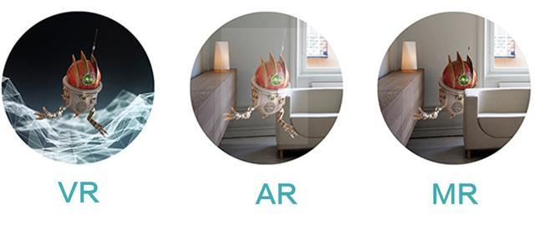

Fig. 14 the distinguish of VR, AR and MR [33]

Summarizing the development characteristics of VR and AR, it can be seen that the application fields of VR and AR are mainly in the field of industrial manufacture and maintenance, displaying various auxiliary information to the user through the head mounted display, including the panel of the virtual instrument, the internal structure of the device, Equipment parts map. Medical areas, using VR virtual reality methods to help doctors diagnose the disease, treatment of patients and training of medical staff. In the field of television broadcasting, the auxiliary information can be superimposed on the retransmission screen by the AR technology. Entertainment, Games, VR Games, VR Videos, Movies and more. In the field of education, the use of VR for immersive teaching; through the AR can text, pictures, three-dimensional, increase reading interactivity and interest. Tourism and exhibition areas. Through VR technology, we can create digital tourist attractions and exhibitions so that users can enjoy the beauty of the world without leaving their homes. The municipal construction plan uses AR technology to superimpose the planning effect on the real scene and obtain the planning results directly.

From the experience of the Last Jedi AR, a Google Pixel phone, to the impressive AR games presented at the Apple iPhone 8 conference, a variety of AR mobile applications can give us a more immersive and realistic augmented reality experience. At the same time, Google Cardboard such a simple VR glasses, priced at less than one hundred yuan, significantly reducing the threshold of user experience virtual reality. Last February Cardboard accomplished two milestones: 10 million Cardboard shipments and 160 million application downloads, all of which make AR / VR more and more appearing in our lives.

* 1. Objectives and Scope

If we make an overview of the research content of this thesis, this paper systematically introduces the development and application status of virtual reality, augmented reality, and mixed reality technologies, and the technologies involved. The use of virtual reality and augmented reality can enrich the existing teaching resources and make the existing educational resources appear in a new form. The static resources are dynamic and multi- dimensional, which is good for the students to understand the learning resources, Stimulate students interest in learning, education and teaching effectiveness. Virtual Reality and Augmented Reality have begun tentative applications in the fields of military, medical, commercial, education, maritime training and have achieved some success.

The Objective of this work is to advance the educational effects towards AR and VR educational applications.

* 1. Contribution

This paper presents several examples of augmented reality and virtual reality applied to education. Through the application of these practical applications to education and teaching, we evaluate each application by scientific methods and obtain the evaluation of their respective educational effects. Through the analysis of the results Get the design and development points for such educational applications. This study aims to obtain the best educational effect of virtual reality applications in education. Here are four applications introduced.

1.3.1 A Board Game - Design of Simple Board Game for Augmented Reality

AR is the integration of digital information with the user's environment in real time [32]. AR is developed based on VR, unlike virtual reality, which creates a totally artificial environment, augmented reality uses the existing environment and overlays new information on top of it. In this paper, we made a board game that can allow multiplayers to play in a combination of realistic and virtual space. In this Board Game, there are 3 characters with different colors and several buttons to control the characters.

1.3.2 A VR Art application - Development of Multimedia Design Contents using Mobile Virtual Reality

Virtual Reality (VR) is widely used in various fields, and it is expanding game and movie toward health care, business Software, education, and web services. Especially various researches are actively conducted in the field of exhibition, utilizing smart phone based detachable HMD (Head Mounted Display). The VR exhibition solves addresses both temporal and special constraints overcoming the unilateral information transfer exhibitions. This paper presents a method to overcome the limitation of time, space, and unidirectional information transfer in offline exhibition, and also presents a new method that utilizes multimedia visual design artwork as VR contents.

1.3.3 AR 3D Color games – Design and Development of Coloring Game based on Augmented Reality Technology by a case study

The development from "virtual reality" to "augmented reality" realizes the combination of the real world and the virtual world. "Supernatural" is no longer a legend. Augmented reality technology is constantly being applied to all fields of society, changing people's way of life and production, and the electronic books designed and developed by using this technology also bring challenges to traditional paper books. Based on the application of augmented reality technology and augmented reality technology in education, this paper takes "Color The Earth" 3D interactive mobile handset as an example, from the aspects of enhancing the characteristics of application, product design and technology realization A more detailed analysis, and design and development of the "Coloring XiXi" application. In order to provide reference for the development of augmented reality mobile applications.

1.3.4 MR Chemistry Lab - A Virtual and Augment Reality Application for Chemical Experiment Education and Practice

Compared with the traditional chemistry experiment teaching, the application can simulate the experimental steps repeatedly and ensure the realism of experimental results because of the high probability of danger and waste of reagents caused by unfamiliar students' reagent, equipment and experiment steps. Reduce the probability of dangerous occurrence and effectively improve the efficiency of learning. In extended applications, the microscopic molecular combination and arrangement structure of the microscopic management system of an augmented reality management system can be applied. Virtual reality (VR) and Argument reality(AR) technology have open a vast opportunity to be applied in many fields include education. This paper is based on a research of the conventional chemistry experiment education limitations, we design and developed a "Virtual Chemistry Lab" propose a new method of assisting present teaching aids. And through analyzing different interaction methods in the VR system, find a better applicable interaction mode for this application. By evaluation, implementation of this application achieved the education objective more effectively.

1.4 Dissertation structure

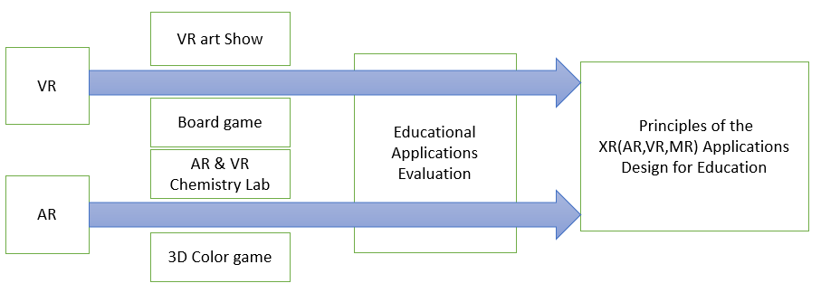

Fig.15 Research papers

# **Ⅱ** VR and AR Background

2.1 Researches

The famous investment bank Goldman Sachs Group in the investor report on the VR / AR market size and population size of the data analysis, including education K-12 stage and higher education stage of the current market size of 50 billion US dollars and 70 billion US dollars, only About 200 million primary and secondary schools in developed countries use VR / AR-assisted education. Goldman Sachs Group also predicted the population size and market size of VR / AR in education field: the number of users will increase to 7 million by 2020 and will reach 15 million by 2025; and the software revenue will reach 300 million by 2020, Rising to 700 million U.S. dollars in 2025 [17].

VR technology indeed has successful application cases in educational, here are some in the K12 classroom (K12 is the North American designation for primary and secondary education. The expression is a shortening of Kindergarten through 12th grade, the first and last grades of free education in the United States and English Canada). In China, more than 14 colleges and universities have their own VR Laboratory, many applications for Early Childhood Education were developed.

VR and AR are both technologies that can be used by college students' smartphones, and higher education has seen AR / VR as the wave of instructional technology. Goldman Sachs predicts that by 2025, about $ 700 million will be spent on AR / VR application development in education, from mechanical operations to building professionals to medical surgery simulations. Market research firm Gartner predicts that by 2021, 60% of higher education institutions in the United States will use virtual reality technology in teaching.

2.2 Educational Applications Typical types and Examples

Although VR / AR technology has not been applied for a long time, it is in accord with educational theory such as behaviorism and constructivism: 1. In behaviorism theory, learning is based on knowledge and the outside world to establish stimulus-response Link [18]. The learning environment created by VR / AR enables learners to be fed back while interacting with the environment and given the next action instructions so that the link between knowledge and response can be adequately built. 2. A large number of construction tools and performance areas provided by the VR / AR virtual learning situation, combined with the subjective initiative of learners, and Piaget's concept and practice of "moving labs to the classroom" and "learning is a Real experience "Constructivism is consistent. Compared with virtual technology, AR can not only simulate the learning object in time, but also put it in a real environment and manipulate the model. Allow students to use a natural means of interaction for independent exploration, cognitive. Its strength is the ability to present information that is difficult to express in a real world and seamlessly integrate that information with the real world so that learning interactions are as natural as interacting in the real world. This is very instructive for teaching abstract content and boosting learner interest.

The New Media Consortium, (NMC), a well-known organization in education, publishes a horizon report every year to introduce technologies that could have a significant impact on education. In the horizon report released in recent years, AR is listed as one of the six most promising technologies in coming years, as shown in Table 1, and the words from "augmented reality" to "augmented reality" Changes can be seen this technology is rapidly maturing. It is noteworthy that this report put VR and AR in parallel in 2016, which shows that the two VR and AR technologies will be used together in education. VR and AR in education in the application of the following types:

**1****.** **Three-dimensional virtual learning environment**

The current development trend of three-dimensional virtual learning environment: First, the user involved in the creation, that is, entirely by the user to create learning content. The second is to provide space for exploration, and learning management system integration. Sloodle (Second Life Object-Oriented Distributed Learning Environment) [28] is a typical case, of course, it is still not perfect enough to three-dimensional virtual environment and learning management system to better heterogeneous two environments also need to have More research workers and practitioners efforts. Third, the virtual and real integration. The reality of the virtual environment depends on the development of graphics, but no matter how it develops, the virtual is virtual after all, and our learning activities are also occurring in the real physical world, "augmented reality" enables learners to carry out There is a better experience when learning activities, and the technology should be more widely used in education. 4. In-depth integration of 3D and AI technologies. Due to the complexity of learning, it is quite difficult for 3D virtual learning environment to be completely human-like, such as automatic answering, automatic paper-making, automatic paper-marking and so on. It needs a breakthrough in AI technology.

**2. AR book**

One of the earliest examples of augmented reality in education was the Magic Book by Bellinghurst [14]. It is based on the book content into 3D scenes and animation, and the use of a special glasses to allow children to see the combination of the actual situation and the background, after which the team has designed and developed a coloring book, the book picture is painted, you can display a painted 3D model with a flatbed [22].

**3. AR Science teaching**

A large number of scholars apply AR to science teaching so as to enhance learners' visual perception of real situations [19]. Clavula et al. [20] demonstrated an example of astronomy teaching in which teachers and students can explore the relationship between the Sun and Earth, day and night by rotating virtual Earth. Cai Su and others [21] combined AR and Kinect somatosensory devices to visualize the magnetic field. When students learn about magnetic fields, they can interact with the device in real time through gestures to understand the distribution and changes in the magnetic field. Researchers at Vienna University of Science and Technology have done specialized mechanical teaching demonstrations [22]. Through physical experiments in the field of simulation physics of AR physics engine, the parameters of mass, force and path of motion are analyzed. However, the use of the system teaching need to configure the more expensive helmets, glasses and other equipment. Magnetic Field Visualization: Visualize the invisible magnetic field using the AR + Kinect somatosensory device and explore the interaction of the magnetic field under different conditions through natural interaction, as shown in the figure, with the magnet moving with the movement of both hands, At the same time constantly changing.

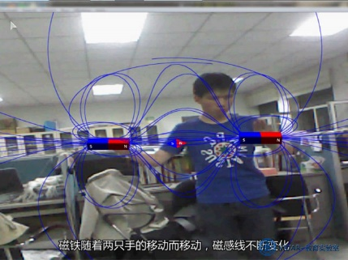

Fig.15 Physical magnetic field visualization

The AR-based convex lens imaging experiment developed by Cai-Su team at Beijing Normal University explored the effect of AR technology on the effect of eighth-grade students' physics learning and deep-seated cognition [23]. The AR-based lenticular imaging aids simulate candles, lenticules, and fluorescent screens by using three different marking cards. When the camera captures a marker card, the 3D model of the lenticular lens with parameters such as the parallel axes used to mark the focal length and twice the focal length data will be displayed on the screen. The candle mark card and the screen mark card are respectively placed on both sides of the convex lens mark card. The screen will automatically present related images based on the distance between the candle and the convex lens. If the distance between the candle and the convex lens is adjusted, the image on the screen will be displayed according to the convex lens Imaging rules change in real time. Suppose the object distance u, like 1u 1 + = v 1f distance v, the focal length f. According to the formula of the convex lens imaging, when u <f, it becomes a virtual image; when u = f, the screen does not appear as an image; when u> f, the screen displays a real image. The experimental results show that AR has a greater impact on students who have lagged behind.

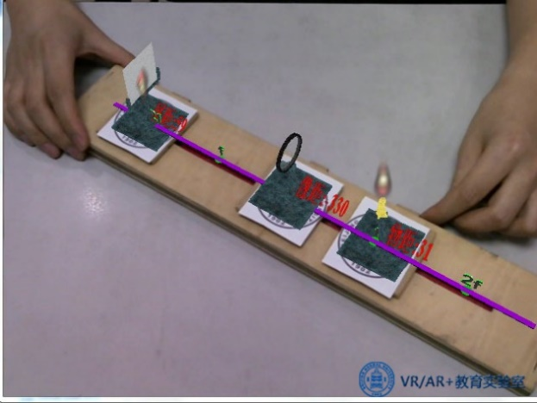

Fig.16 Simulated convex lens imaging

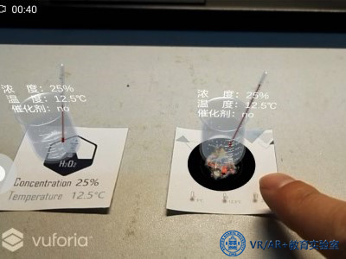

Fig.17 Chemical hydrogen peroxide

Combining PC or tablet teaching, using AR technology and naturally interacting to control conditions such as temperature, concentration, and catalyst, it explores how it affects chemical reactions.

Research shows AR tools can help students remember the structure of atoms better. In traditional classrooms, students' understanding of knowledge and persistence of memory are low only through simple instruction of the teacher. However, teaching based on AR software can mobilize the enthusiasm of students, prompting their attention more focused. After seeing and interacting with the simulation model intuitively, students are also more impressed with what they have learned. AR tools improve students' ability to operate in experimental exploration. Compared with the keyboard, mouse and computer operation, directly through the AR technology to improve activity sense of participation in this way the recognition of procedural knowledge better. At the same time, students also put forward some suggestions on this tool. For example, they hope that the simulation of material can be more realistic. In addition, cartoon or animation elements can be added to make the software more interesting.

The basic idea of virtual reality technology in VR teaching is to make people feel immersive in solving problems. In VR teaching, you can completely break the time and space constraints, the use of virtual reality technology, the boring the data becomes vivid graphics of virtual reality, so that vocational education into a new era of interactive participation.

The application of VR teaching in experimental education and practical education is the trend of educational technology development, and the cost of inputting is not very high. Its advantages are mainly reflected in the following points:

1, Reduce funding

Greatly reduce the investment in education funds to ease the educational institutions lack of funds to reduce the waste of resources and save a variety of experimental raw materials.

2, The experiment can be repeated, so as to improve the skill level

The use of virtual reality technology, you can do a wide range of skills training, and can be repeated. Such as surgical skills, teaching skills, sports skills, car driving skills, fruit tree cultivation skills, electrical maintenance skills and other skills training. Students can take the trouble to practice repeatedly until they master the skills. For example, in a virtual aircraft driving training system, students can repeatedly operate control equipment to learn to take off and land in various weather conditions, and through repeated training, achieve the purpose of mastering driving skills.

3, To avoid the real experiment or operation of the various dangers.

In the past, dangerous or harmful to human health experiments, the general use of video recording instead of the experimental method, students can not directly involved in the experiment, access to perceptual knowledge. Using VR virtual reality for virtual experiment, you can avoid this concern. Students in the virtual experimental environment, you can safely do all kinds of experiments, will not appear outside. For example, a virtual chemical experiment can avoid the danger of burning, explosion caused by chemical reactions. Virtual surgery experiments to avoid mistakes due to student operation. Virtual car driving teaching system, students can be exempt from operational errors arising from accidents. The virtual airplane pilot system will not crash the plane.

**4. AR Language teaching**

Use your tablet or phone to scan a card to recognize the word, then render the corresponding picture or 3D model and pronounce it, which is good for children to learn spelling and pronunciation of words. The study shows that this learning combines tactile, auditory and visual features, which can stimulate children's enthusiasm more easily than traditional teaching methods, and has significant effect on learning words of non-native English learners. Using a cell phone to scan words, render matching pictures and pronunciation is also consistent with children's cognitive rules, but the phone may distract children's attention. This type of teaching may be more suitable for one-on-one situations.

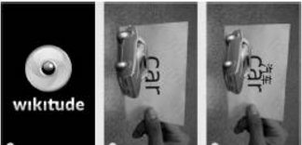

Fig.18 Happy to learn English interface

Chocolate company developed the VRCLASS chocolate interaction Starting from 2014 to develop a virtual reality immersive learning system, users can exposure to various scenes personally feel the charm of the future learning styles, and interact with remote teachers interact; teachers can give full play to the virtual The infinite possibilities of space, easy to achieve the traditional classroom teaching methods can not be achieved.

A class of 50 minutes, the first 30 minutes of traditional teaching, the teacher will recognize students spelling words, such as giraffes, tigers, lions, the last 20 minutes will allow students to use the VR head into the virtual world interaction, which can be consolidated The effect of learning. Parents also generally believe that this teaching is very effective.

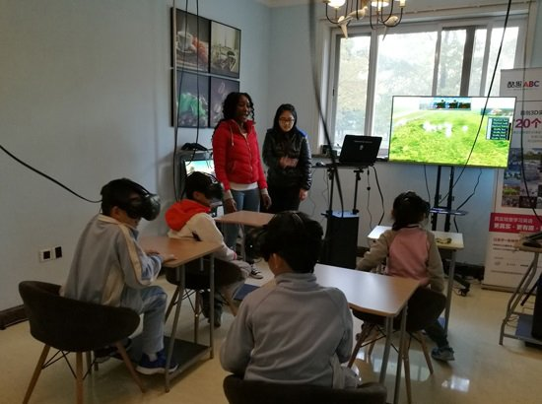 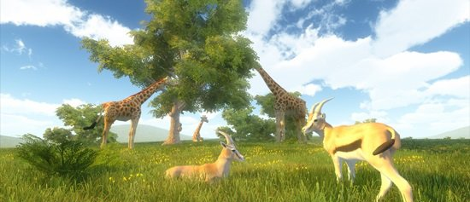

Fig.19 Cool fun ABC immersive children English learning [29]

**5. Location Based AR Learning**;

During use, the user can find the campus related buildings according to the real scene captured in the camera, as shown in FIG. 11. Upon reaching the target building, the camera automatically recognizes the building information by capturing the image and presents it as a learning content to the user. The vast majority of subjects mentioned the use of mobile phones to obtain information anytime, anywhere, and the combination of positioning technology and augmented reality technologies made the search process and presentation more natural, eliminating the need for manual entry and seeing The vast majority of subjects mentioned the current waste of resources when using paper maps, and that the software is an alternative to paper media, one of the better means; most of the subjects are mentioned using mobile phones The way in which the camera interacts with the real physical environment is very new and interesting, has not been exposed before, and the quick, instant presentation of information has made campus culture readily available. Users also made a lot of constructive comments on the software. Some opinions are limited to the current hardware technology capability. For example, the slow speed of campus wireless network results in too slow loading information, the time required for GPS positioning of the mobile phone is too long and sometimes it is not located Accurate and so on.

**6. Other applications**

ChinAR: Facilitating Chinese Guqin Learning through Interactive Projected Augmentation,Yingxue Zhang, Siqi Liu, Lu Tao, Chun Yu, Yuanchun Shi, Ying-Qing Xu, CCHI2015. Lower the threshold of Guqin learning, is conducive to the most ancient Chinese instrument to flourish. Guqin is good, but I learned from my classmates teaching Guqin at school that most people chose to give up after learning Guqin for a month. Different from other musical instruments, Guqin has its own set of music system. The entry requires learning and adaptation of many new concepts and methods. In this respect, the threshold of entry is higher than that of other instruments. This essay, by enhancing learning techniques, gives beginners a lot of "hints," greatly reducing the threshold for entry learning, and combining Chinese and foreign related musical theories to design a complete set of interactive methods.

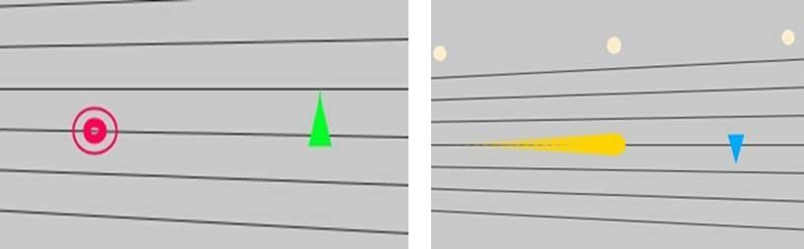

Fig.20 Chinese Guqin Learning Application

2.3 Interaction Design

2.3.1 The develop of Human-centered Interaction Design

Human-computer interaction refers to the exchange of information between a person and a computer, including a computer providing information to people through an output or display device, and a person entering information into the computer through an input device. The purpose of human-computer interaction is to discuss how to make the computer designed to help people to be more safe and reliable, more efficient to complete the task to be completed. Mainly experienced in three stages.

1. Multi-language User Interface

Inefficiency. Human-computer interaction began with the emergence of the world's first computer ENIAC, the operating system is the way to complete the order is, then bring more people to the computer's mystique, language barriers give a strong professional sense. Need to master a computer language proficiency, otherwise the interaction process is inefficient.

1. Image User Interface

Operational, graphical user interface is the mainstream of the current user interface, represented by the United States Microsoft, which fundamentally changed the situation in the past to remember a large number of language forms. A common feature of current GUIs is that they convey and display information through windows. In addition, they are operated by using keyboards and mice. Because image-based user interfaces rely heavily on visual Recognition and manual control, so this interface is easy to operate.

1. Multimedia User Interface

Multimedia technology is a transitional technology before the emergence of naturalized interactive design technology. Before the advent of the multimedia user interface, the user interface design had completed the transition from language to graphics. However, with the development of multimedia technology, the introduction of animations, audio and video media into this technology, especially the introduction of audio media, has greatly enriched the computer's expression of information to better serve people Control and communication of information to create a very good condition, greatly improving the efficiency of human-computer interaction. The main advantage of the multimedia user interface in human-computer interaction is that it can improve people's recognition of information and its choice, as well as the ability to control the information. In addition, the interaction between the computer's representation of information and human recognition Great improvement.

2.3.2 Interaction Design for VR and AR

Since 2014, the advent of virtual reality entertainment devices such as Oculus, Gear VR and HTC Vive has enabled VR technology to serve ordinary consumers, thus detonating a world-class VR industry revolution. People enter a new era of human-computer interaction: the computer constructs a real-world three-dimensional world for the user to use the sensory interaction directly through the sensory simulation technologies such as vision, hearing and touch. The user is no longer an isolated individual but a virtual Part of the environment, people and machines to establish a natural link between. This natural interactive nature of the failure of the two-dimensional screen-based design rules, designers must find a reasonable interaction design method to eliminate the gap between human and computer virtual environment, to create a more natural VR experience. [10]

VR interacts in various ways, but in terms of current interactions, it is neither eye-tracking nor gesture-based tracking. Instead, in the form of a handle, tactile feedback acts as the main method of interaction. The interaction of virtual reality is divided into input part, output part and virtual environment information. The virtual reality system accepts information from the user through the input part. The basic signal of the user includes the position and direction of the user's head and hands. Common input devices have data. Gloves, space seeking, three-dimensional floating mouse, biosensor, head tracker and voice input device. At present, VR has the following interaction modes:

1, motion capture

Full-body capture is not necessary in many situations. Another problem is that there is no feedback. It is difficult for users to feel that their operations are effective. This is a major pain point for interaction design.

2, tactile feedback

Here is the main button and vibration feedback, which is a large class of virtual reality handles that will be mentioned below. At present, the three major VR head-display manufacturers Oculus, Sony, HTC Valve all use virtual reality handles as standard interactive modes: two-hand discrete, 6-DOF space tracking (3 rotational degrees of freedom, 3 translation degrees of freedom) , handle with button and vibration feedback. Such devices are obviously used for some highly specialized game applications (as well as light consumer applications), which can also be considered as a business strategy, because the early consumer of VR headsets should be basically a game player. However, the advantage of such a highly specialized/simplified interactive device is obviously that it can be used very freely in applications such as games, but it cannot adapt to a wider range of application scenarios.

3, Eye tracking

When it comes to the most important technology in the VR field, eye tracking technology is definitely worth paying close attention to practitioners. The founder of Oculus, Palmer Rudge, once called it “the heart of VR” because it detects the position of the human eye and provides the best 3D effect for the current viewing angle, making the VR head appear as an image. More natural, less delay, which can greatly increase the playability. At the same time, because the eye tracking technology can know the actual fixation point of the human eye, the depth of field of the viewpoint position on the virtual object can be obtained. Therefore, eye tracking technology is considered by most VR practitioners to be an important technological breakthrough in solving the problem of virtual reality helmet vertigo. However, despite the fact that many companies are researching eye tracking technology, there is still no satisfactory solution.

4, Gesture tracking

The use of gesture tracking as an interaction can be divided into two ways: The first is the use of optical tracking, such as depth sensors such as Leap MoTion and Nimble VR, and the second is the use of data gloves on the sensor. The advantage of optical tracking is that it has a low threshold for use and the scene is flexible. The user does not need to put off the device on his/her hand. In the future, integrating the optical hand tracking directly on the integrated mobile VR head tracking as the interactive mode of the moving scene is very feasible. thing. But its disadvantage is that the field of view is limited, as well as the two basic problems we mentioned before: The interactions that require the user to make mental and physical efforts are unsuccessful. Using gesture tracking can be tiring and not intuitive, and there is no feedback. This requires good interaction design to make up for.

5, Data gloves

An inertial sensor is generally integrated on the glove to track the movement of the user's finger or even the entire arm. Its advantage is that there is no field of view limitation, and it is entirely possible to integrate feedback mechanisms (such as vibration, buttons, and touch) on the device. Its drawback lies in the high usage threshold: the user needs to wear off the device, and its use scenario as a peripheral is still limited: it is like saying that it is unlikely to use the mouse in many moving scenes. However, these problems have no absolute technical threshold, and it is entirely conceivable that highly integrated and simplified data gloves like the ring will appear in the VR industry in the future, and users can carry it with them at all times. These two methods have advantages and disadvantages. It can be imagined that in the future, these two kinds of gesture tracking will coexist for a long time, and users will use different tracking methods in different scenarios (and different preferences).

6, direction tracking

In addition to direction tracking, aiming points can also be used to control the user's direction of advancement in VR. However, if you use direction tracking to adjust the direction, you may not be able to transfer because the user does not always sit on a swivel chair that can rotate 360 degrees, and may be limited in many cases. For example, if you turn your head 90 degrees and then turn your body, it's hard to turn 180 degrees together... So here's “Space Constraints Can't Turn Around Is a Demand,” so the interaction designer gave a solution—pressing the mouse Right-clicking can return the direction to the original frontal direction or the direction to reset the current gaze (that is, the direction you originally faced), or you can use the joystick to adjust the direction, or press the button to return to the initial position. However, the problem still exists, with the direction of the user facing the direction of walking compared to the keyboard and mouse and the gamepad, the matching of steering and vision greatly enhances the sense of immersion, but it may be very tired and the comfort is weakened.

7, voice interaction

Voice interactions drown users with VR's massive amount of information. He does not care about the visual center's instructions, but looks around and discovers. If you give some graphic instructions at this time will interfere with their immersive experience in VR, so the best way is to use the voice, and they are watching the surrounding world without disturbing each other. At this time, if the user interacts with the VR world by voice, it will be more natural, and it is everywhere and at all times. Users do not need to move their heads and look for them, and they can communicate with them anywhere in any direction.

8, Sensor

Sensors can help people interact naturally with multidimensional VR information environments. For example, people enter the virtual world not only want to sit there, they also want to be able to walk around in the virtual world, such as universal treadmill, Virtuix, Cyberith and domestic KAT are developing this product. However, experienced people have reacted that such a treadmill is not actually able to provide a feeling close to real movement, and the current experience is not good. Another idea is to use the inertial sensor on the foot instead of going forward, such as Stompz VR. Also, for example, the full-body VR suit Teslasuit, wearing this equipment, you can feel the changes in the virtual reality environment, such as blowing the breeze can feel the breeze, and even feel the shot in the shooting game feel. These are generated by various sensors on the device, such as smart inductive rings, temperature sensors, light sensors, pressure sensors, visual sensors, etc., which can make the skin produce a corresponding feeling through pulsed current, or touch and sense of smell in the game. Various kinds of perceptions are transmitted to the brain. However, there are currently not many high-end devices that use sensors, and there are still many technical breakthroughs that need to be made.

9, Virtual Reality Theme Park

The virtual reality theme park The Void uses this approach. It is a mixed-reality experience that builds the virtual world on top of the physical world, allowing users to feel the surrounding objects and use real-world props, such as portable lights. , swords, guns, etc., Chinese media called it "the strongest surface recreation facility."

2.3.3 User Interface Design for VR and AR

Augmented reality achieves enhanced results by providing timely feedback on real-world dynamic changes. This is different from virtual reality. Virtual reality isolates the user from the real world, presenting the user with a virtual environment consisting mostly of elements created by . However, virtual reality and augmented reality are both real-time and provide timely feedback on the user's behavior and interaction in the environment. The user interface is a connected window.

Now the Unity development environment mostly uses the original screen interaction, which is divided into interface interaction and model interaction. The model interaction is more of a kind of gesture interaction, which is the screen-aware gesture that we can use now and then make feedback interaction. the way. And the feedback effect Unity can achieve is far less than the designer wants to do, including model effect feedback and interface feedback. It is too early to discuss the future of virtual interaction, because the way of interaction not only changes with the improvement and development of technology, but also changes with the changes brought about by the development of technology. Now people are more accustomed to the interaction on the screen, so even if there are new technological drivers, it's a process that people accept. Now that AR technology has developed to such a level, Ali’s AR red envelopes and AR scans are “blessings”. They are all relatively elementary ARs. He is slowly promoting people’s perceptions and living habits. At the same time, it is also a look at people's reactions and attitudes towards this, so talking about future AR/VR interactions is nothing more than a vacuum.

The flat interface design can be used along the AR/VR interface. The AR technology can superimpose virtual objects onto the real world, fuse and interact with each other. However, in order to use a complex real environment as the “background canvas”, the design of the GUI must focus on how to better present information and facilitate browsing and interaction. Then the advantages of Flat Design are reflected: 1. Better presentation of content and data, avoiding too many visual elements to interfere with information identification; 2. Applicable to the effects of transparency, allowing users to observe the external environment. Take the Google tilt brush example. This is the Color picker provided in the software, which is similar to what we usually use in desktop software (flat style), instead of giving you a box of "pigment" to color slowly.

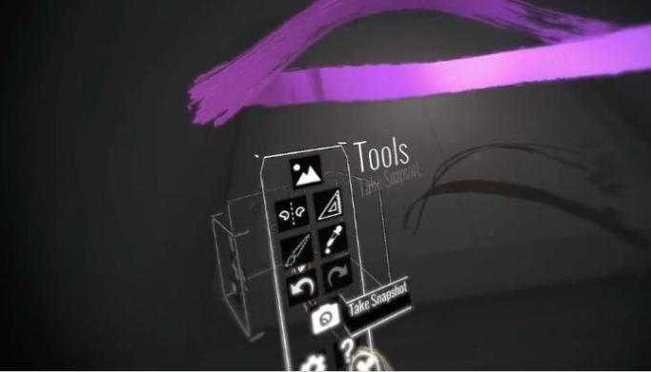

Fig.22 Flat Design User interface in Google tilt brush

2.4 Summary

Using AR and VR for education has enriched educational resources and improved the way of education. To a certain extent, it can supplement the existing shortcomings of traditional education. However, each application must find a suitable binding point, according to the needs of reagents, custom design programs in order to achieve the best educational results.

First of all, VR + Education, in terms of product content, the hardware configuration and subject education is low, and the development of VR education curriculum lacks the participation of subject education experts and teachers. Compared with pure virtual reality environments such as Oculus and HTC Vive, the augmented reality environment does not need to wear a heavy helmet, and does not need to place a dedicated locator to capture user space locations and a specific activity range space. It only requires a computer to work with a normal camera, or just a tablet or mobile phone (it comes with its own camera), and it can achieve the integration and interaction of the real environment and virtual objects. Therefore, this kind of learning technology with less demanding hardware conditions is easier to land at school and has more audience users. More importantly, the augmented reality environment has meaningfully linked virtual learning content with the real world. Therefore, AR technology as a branch of VR technology, one of the current research hotspots, can create a scientific inquiry environment for students[14]. The famous publication “The Economist” wrote an article in early 2017 predicting that AR is more promising than VR [15].

 Secondly, AR+Education is still in the initial stage of simple presentation and immature interaction. There are still many parts that need to be developed for the study of AR empirical research topics. It is worth mentioning that the team of the Institute of Modern Education of Beijing Normal University has conducted long-term empirical research on key technical problems such as 3D modeling and virtual behavior interaction in augmented reality education applications, and has achieved breakthrough results.

Through its empirical research, it can be seen that most students show a positive attitude towards VR/AR teaching tools or environment, which is also consistent with the results of Núñez et al. [23]. Therefore, in the future education, we should dig deep into the laws of education, use the VR/AR learning environment, and build a new teaching model supported by the technology platform to explore how the VR/AR learning environment supports learning and teaching so as to improve students’ classroom teaching. The effect of learning returns to the essence of education by reshaping the learning style and provides support for cultivating innovative talents and education.

# Ⅲ. **A Ludo Game**

Ludo game is a common toddler game, which is of great significance to the physical and mental development of young children. It consists of three parts: chessboard, chess pieces, and dice. Ludo games are designed from the perspective of the main purpose of the following aspects: involving logical ability training, Strengthen attention and observation, but social development, including awareness of rules, competition and cooperation, and the relationship between winning and losing. The third is mathematical logic training.

3.1 Implementation Method

Through the previous introduction, we learned that there are many ways to achieve AR technology, one of which is the three-dimensional registration technology, three-dimensional registration technology is to obtain the precise coordinates of an object in three-dimensional space, and then according to the coordinate information obtained will be placed in the corresponding virtual information In the three-dimensional scene, the virtual reality is used to enhance the real scene. Three-dimensional registration is a key technology in augmented reality. The accuracy of the registration is related to whether it can achieve an effective enhancement of the real scene, but also to judge whether the augmented reality technology can The most widely used and most intuitive standard, the integration of virtual information is the final link of an augmented reality system, and is the ultimate result of augmented reality. At present, three-dimensional registration can be divided into registration-based registration technology and registration technology based on natural features. The two AR applications studied in this paper are based on identification, and registration technologies based on natural feature points can be roughly divided into two categories: hardware-based Three-dimensional registration technology and vision-based three-dimensional registration technology, hardware-based three-dimensional registration technology requires higher hardware facilities, resulting in expensive registration, and based on that three-dimensional registration technology is less call charges, and registration accuracy is acceptable, such as:

1, through the identification map

The way to display the model by recognizing the map can be done by uploading the image to the Vuforia website. The resource package can be downloaded and imported into the unit. In the AR development process, many people will feel that uploading the identification map to the official website database and then downloading it from the database is inevitably complicated. The second way is to create a recognition map in real time when used, that is, a custom target recognition map. After opening the camera to start scanning, using a fixed scene as a recognition map, the method to achieve this step is to use the camera to take a picture. At this time, an instruction to trigger the photographing is needed and a button is used to implement the photographing. When we scan to the identification map that we want to customize, press the button, and then the identification map is created, scan the identification map, and the model appears. In addition, custom identification maps do not support virtual keys. Since flying chess requires a standard board, this method does not guarantee the standardization of the scanned board. Since this game requires a checkerboard with a standard aspect ratio, this application uses the method of uploading to the Vuforia database and then downloading the resource pack to identify custom images.

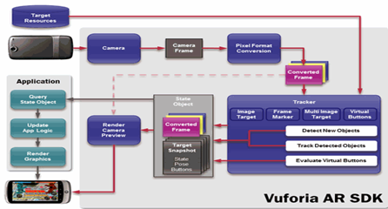

Fig. Data flow diagram of Vuforia SDK [ ]

The data stream of Vuforia SDK is divided into four modules: inputting, database, tracking and matching and render output [32].

2, through the use of AR SDKs to identify planes

Current mainstream development tools include Google’s Project Tango and AR Core, launched in December 2017, and Apple’s AR kit. Tango's hardware requirements are too high, and ARCore does not use software to achieve AR effects. Tango's AR effects are mainly achieved through special hardware such as depth cameras and sensors. Because of this, to run Tango, the received hardware must reach a certain level of technology. . So far, only ASUS, Lenovo and the two companies have withdrawn enough to support Tango mobile phones. So, ARCore came into being, he does not need dedicated hardware, does not require expensive mobile platforms, just to rescue Google from the hardware's plight, compared to Tango's two models are very poor, was born in Andrews this huge ARCore in the hardware world can say no hardware at all. At present, Google AR Core only supports Google Pixel and Samsung Galaxy S8 devices. Google said that they are actively working with Samsung, Asus, LG, Huawei and other vendors. It is expected that in November 2018, there will be more than 100 million. Users can access ARCore's applications. On the developer side, ARCore supports most of the development platforms, including Unreal, Unity, Vofuria, Java, OpenGL, and even Web.

3.2 Game design

Remember the flying chess that I played when I was young? Now we have moved it to the phone. Based on AR augmented reality technology, "AR Flying Chess" bid farewell to the old messy parts, just a recognition map, pick up the mobile phone swept, you can integrate the virtual chess board into the real world, let you experience through the mobile phone based on Real-world virtual interaction.

The characteristics of the AR flight chess: AR combined with virtual reality technology allows you to be anywhere. The following figure shows the chess board for flying chess.

AR is the integration of digital information with the user's environment in real time [32]. AR is developed based on VR, however, unlike virtual reality, which creates a totally artificial environment, augmented reality uses the existing environment and overlays new information on top of it. In this project, we made a board game that can allow multiplayers to play in a combination of realistic and virtual space. In this Board Game, there are 3 characters with different colors and several buttons to control the characters.

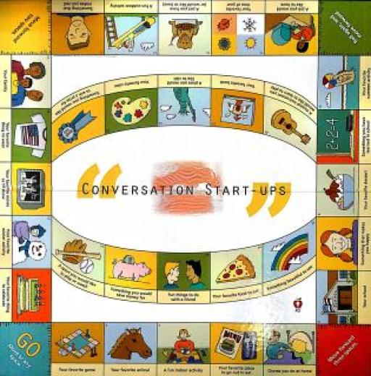

Fig.23 The board of the game（Identification pic）

In this project, we made a board game that can allow multiplayers to play in a combination of realistic and virtual space. In this Board Game, there are 3 characters with different colors and several buttons to control the characters.

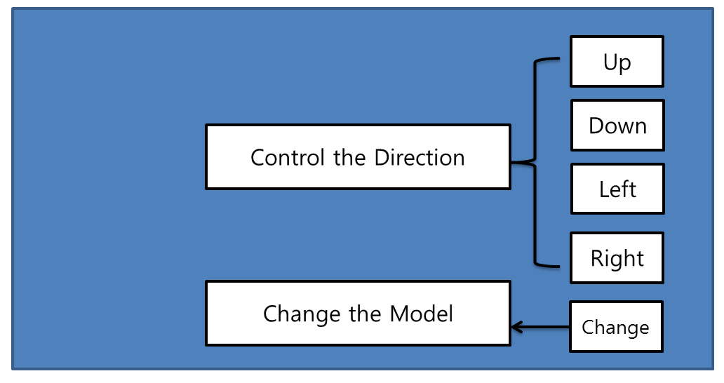

Fig.21 the board game Flowchart

A player has played on a specially designed board. The games have been played in most societies and cultures throughout history [4]. Especially the games that are based on strategy placed on a pre-marked surface according to a set of rules [4]. Molla et al. have been studies how to transform actual game into game of Augmented Reality by using a simple webcam [5]. For mobile AR games are several interaction studies like the potential of interaction based on finger movement via camera [6]. The Sphero [7] focuses on both tangible interfaces and physical around players and increases enjoy ability and immersion. Vancouver Maneuver [8] has created a cooperative board game experience by using Augmented Reality for mobile devices. The game provides both digital and analogue board game design like hybrid game design approach.

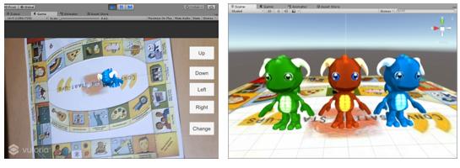

(a) Beginning the game (Game Scene) (b) Game Models

Fig.25 Result of designed Game

3.3 Project Implementation

The Experimental environment for this development is Intel(R) Xeon(R)CPU E3-1240 v3 @3.40GHz 3.40GHz, RAM 8GB with window 10 and using software include version 5.5.2f1 personal (64bit) of Unity3D and Vuforia unity-6-2-10 unity package for AR. We have implied the game in a mobile device such as an android. Fig. 2 shows the result of designed game.

(Qualcomm) is an AR company that provides the Unity plug-in to develop AR products. Use the upload identification map to the Qualcomm Vuforia repository.

1. New project and import Vuforia plugin into Unity

2. Upload the picture to the official website, download the corresponding picture data package, Qualcomm (Qualcomm Vuforia) will identify the degree of recognition for the recognition map (star), identify the figure in the project at least Samsung.



Fig.26

3. Delete the MainCamera in the original scene and drag it into the ARCamera in the vuforia prefab, ImageTarget

4. Import three models into hierarchical view Hierachy

5. Click OpenVuforiaConfiguration under VuforiaBehaviour under ARCamera and enter LicenseKey.

 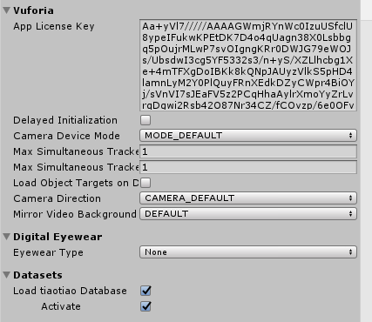

1. (b)

Fig.27 add key

Then set the ImageTarget type to Predefined (UserDefined if it is user-defined).

6. Write the script. In the default script named Default Trackable Event Handler.cs on the ImageTarget, you can use state + control to complete the switch after recognition. If you want to identify multiple images, you can create multiple ImageTargets.

TrackableBehaviour.Status.DETECTED//检测到TrackableBehaviour.Status.EXTENDED_TRACKED//延伸跟踪

TrackableBehaviour.Status.NOT_FOUND//未找到

TrackableBehaviour.Status.TRACKED//跟踪中

You also need to have a script that controls the character name Move.cs, hang it under player, and then drag the three model prefabs to the script variable.

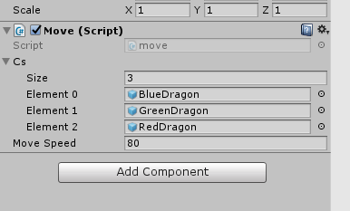

Fig.29

for (int i = 0; i < 3; i++)

{

Cs[i].SetActive(false);

}

modelId_ = ran.Next(0, 3);

C_now = Cs[modelId_];

C_now.SetActive(true);

C_now.transform.parent = this.transform;

Set up the UI

There are buttons and reality in the UI section of this game. There are 5 buttons in this game screen to adjust the direction, and a text display box is used to display the number of steps.

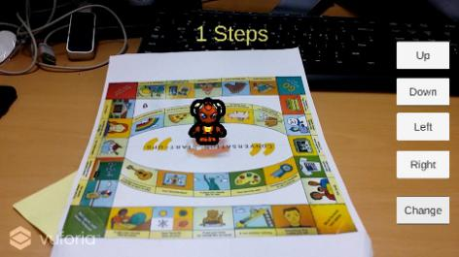 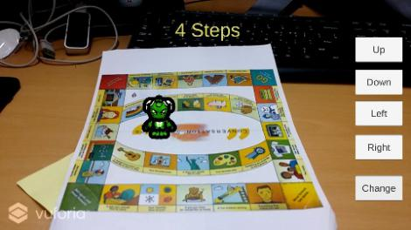 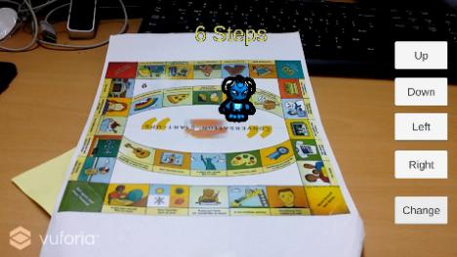

Fig.30 game scenes

# 3.4 Conclusion

AR technology was released in 2018 from Apple's ARKit and Google Android's ARCore. Millions of smartphone users can only perform software updates to enhance their performance. So the AR application, through the camera lens, allows virtual objects to be displayed in superposition in the real world. Snapchat and Facebook have enhanced their application's camera capabilities to augment things in the real world. In 2018, there will surely be a large number of AR applications in the market that will be accepted by the general public. At this year's CES, AR technology demonstrated the potential of holographic displays to enter people's daily lives in large and small ways.

# **Ⅳ**. **VR Art Exhibition**

The virtual art display application can allow users to appreciate and analyze art works at any time without leaving home, which breaks the time and space constraints.

4.1 Implementation Method

Virtual Reality (VR) is widely used in various fields, and it is expanding game movie towards health care, business software, education and web service. Especially various researches are being conducted in the field of exhibition, and methods for implementing Attachable-removable HMD (Head Mounted Display) VR contents using a smart phone are being presented. The VR technology in the field of exhibition solves both the time, space constraints and the unilateral information transfer to the exhibitions displayed in the offline exhibition. The advantage has that this can overcome the quantity, time and the geographical constraints that should be met by direct visits. This paper presents a method to overcome the limitation of time, space, unidirectional information in offline exhibition, and also presents a new method that utilize multimedia visual design works as VR contents.

In the Mobile +VR device, the Samsung Gear VR is indeed much more closed, but you must have one of the newer phone models such as the Galaxy S6, Galaxy S6 edge, Galaxy Note4, Galaxy Note5, and Galaxy S6 edge+. Google Cardboard is a good choice as a VR entry-level experience, mainly because the cost is relatively low and most people buy it. And Android and Apple's most mobile phones can be used. In the Google Cardboard introduction page, there is such a sentence "Experience virtual reality in a simple, fun, and affordable way" summed up Google Cardboard has the following advantages compared to other mobile VR products: 1, cheap, 2, easy to carry, 3, while supporting all Android screens and IOS phones with appropriate screen size. Therefore, this game selects Google Cardboard as a game device.

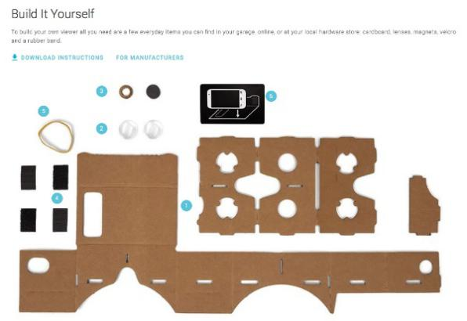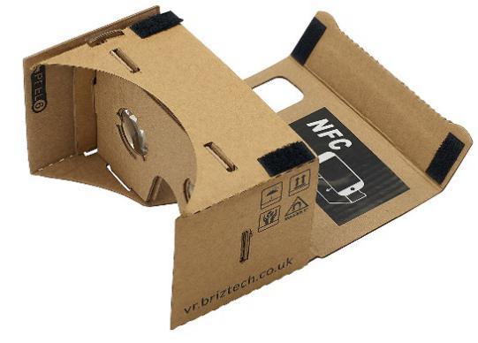

Fig.32 According to the guideline, users can personally do Cardboard

4.2 Game Design

This application is a multimedia mobile visual VR application using Google Cardboard's multimedia visual design. Users can experience the virtual art exhibition from the first viewing angle after being worn by the user. Because Google Cardboard and mobile phones support simple interaction, we have used the line of sight here. Control the way to move. After the application starts, the user's line of sight follows the character and moves toward the user's direction. When the user enters the painting or the obstacle in front of a certain distance, the user can stop the painting. When the line of sight changes, the user continues to move.

4.2.1 Composition of contents

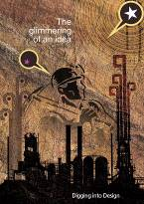 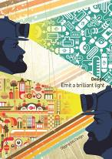 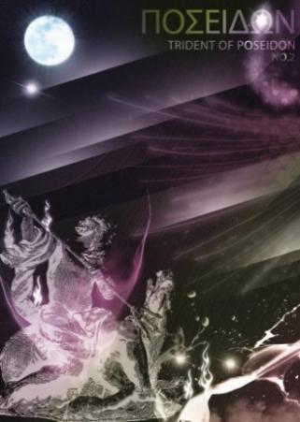

Fig.32 Work of Arts

4.2.2 Immersion for VR exhibition

Basic HMD devices all have basic experience and immersion, but the factors that hinder immersion are defined in [33] as follows: The smaller the screen size is, the smaller the stereoscopic effect is, and the movement is not able to react well. The lower the resolution of the picture, the lower the immersiveness. From the aspect of experience, HMD is also one of the factors that hinder the immersion. The result of the user's free movement and the reality are different. Therefore, the immersiveness is raised in the following table. The solution:

Table 1: Influencing Factors of Sense of Experience and Immersion in Virtual Reality Display

|  |  |
| --- | --- |
| Distinguish | factors of experience and immersion |
| Display Performance | Shading ratio, color reproduction rate, color temperature, grayscale |
| Image Resolution | The difference between the entity comics and the digitized image. |
| Image Size | The difference in the picture size of the HMD system was used. |
| Displaying the layout of the work | When a three-dimensional virtual reality environment is composed, effects such as “shadow” with lighting as background |

4.2.3 Interaction Design and Operating Mode

In terms of user interaction, in order to use Google Cardboard as a tool to watch multimedia exhibits, the interaction mode is particularly important, especially if you want to approach the actual exhibition, the interaction mode must follow the natural interaction as much as possible, through analysis of the hardware conditions of Google Cardboard, Using the way of the user's line of sight to interact, the user in the virtual world automatically advances toward the line of sight defense at the first viewing angle, and stops when entering a certain range near the obstacle. At this time, the user may stop to view the painting or pass through. Change the direction of the line of sight to change the direction of movement.

4.3 Project Implementation

This application uses Unity 3D 5.1 as a development tool. Unity has built-in support for virtual reality from 5.1. Download CardboardSdkForUnity. Packadge and import it into Unity project. In game level hierarchy panel, use Cardboard Main Prefab instead of standard camera in project setting. Check the Virtual Reality Supported option and the game can be switched to VR mode preview.

The following is the main code for the user to move and determine the obstacle part:

float walk_speed = 2;

void Update() {

Ray ray= new Ray(); // Create ray

RaycastHit hit; // Collision

if(Raycast) //Collision check

{ Transform.translate(forward, walk_speed); // forwarding

float distance = vector3(position.hit, position); // calculate distance

if(distance < 3) { // check distance to wall walk_speed = 0;}

else { walk_speed =1;

}

}

}

The application development environment is Windows 10 64bit, Unity3D 5.1, and the development language is C#. The hardware devices used include Google Cardboard and Samsung S4 smart phones. The following figure shows the program execution screen and various visual design contents in a virtual environment. The viewing effect and experience are not inferior to those in the real world exhibition hall.

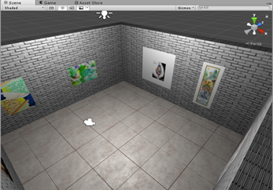 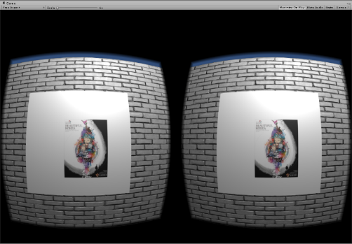

（a） (b)

Fig.33 Game Scnens

4.4 Conclusion

Nowadays, smart phones have become popular and become our daily necessities. Through smart phones, various applications can be easily used. Using Google Cardboard also allows users to have a better experience. For those who are keen on appreciation of works of art Say, you can visit art exhibition anytime and anywhere. This study analyzes the factors that affect user experience and immersiveness in this trend, and proposes ways to improve user experience and immersion based on existing conditions.

# **Ⅴ. AR 3D Coloring game**

Through the development of this AR educational game, the flat object can be “moved on the paper” by a simple and portable scan of the mobile terminal. The multiple forms of interaction stimulate the interest of the learners and enable them to interact with the three-dimensional “partners”. Learn knowledge and understand the world. Break through the limitations of the paper book, promote the acquisition and absorption of knowledge, improve the interactive effect of teaching, and fit in with the concept of entertaining, improve the students' ability to operate, recognize the ability of literacy and identify colors. In the future, through further improvement, with the advancement of smart classrooms and digital learning, augmented reality e-books as emerging learning media will have a disruptive impact on classroom environment, teaching model, and even education.

5.1 Implementation Method

At present, augmented reality technology has begun trial application in military, medical, commercial, education, and maritime training and achieved certain results. The combination of education and AR technology has created a spatial three-dimensional material for learners while at the same time promoting the deep integration of technology and teaching, so that both as a teaching content or as a teaching tool can promote the internalization of knowledge absorption and bring about innovation and development in education [5]. At present, the application of AR technology in the field of education is mainly reflected in the following aspects: AR-based classroom teaching; AR-based skills training; AR-based mobile learning.

AR technology is a combination of virtual image and reality. Interaction should be the main focus of AR. However, due to the fact that smart glasses are not formally listed, AR technology still stays on the screen of mobile devices. This results in many AR technologies. As a kind of gimmick, taking the acceptance visual experience as the mainstay, coloring AR products are a few successful products in the current AR market. They have the following characteristics: high interactivity and entertainment; they can be used independently or as part of the system. , less investment than traditional games; collaboration between different areas, mapping UV matching requires a higher calculation. In the market for some color AR applications, the main feature of the colAR Mix is ​​that the models and animations are more complex and interactive, AR TuTuLe. Color rendering AR two ways of expression: 1, real-time rendering model texture content; 2, only once the model texture is not real-time rendering content.

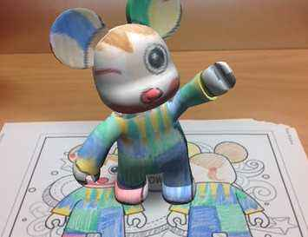 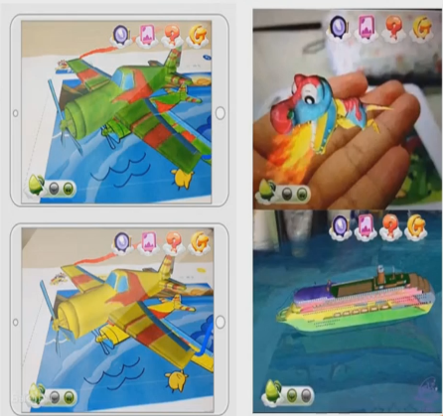

1. (b)

Fig.34 AR 涂色类应用ColAR Mix(a); AR TuTuLe(b)

5.2 Game Design

In this article, according to the knowledge and methods of AR painting application development, a fun cartoon character painting and dressing application suitable for young children was developed. This application can be run on the mobile device with simple operation and strong mobility. Need a few pieces of paper or cards to experience anytime, anywhere. The design motivation of this application is to help children recognize colors and express their desired combinations through coloring and collage. Young children can also observe their designs and collocations from all angles.

This game consists of two parts: AR and AR+ as shown in Fig. 35.

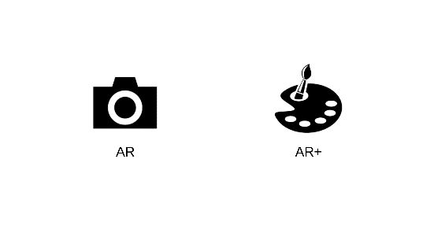

Fig.35 Start Scene

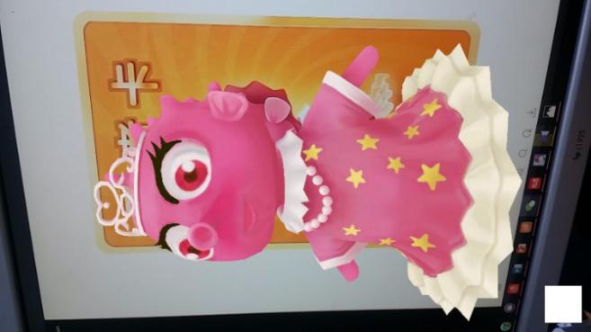 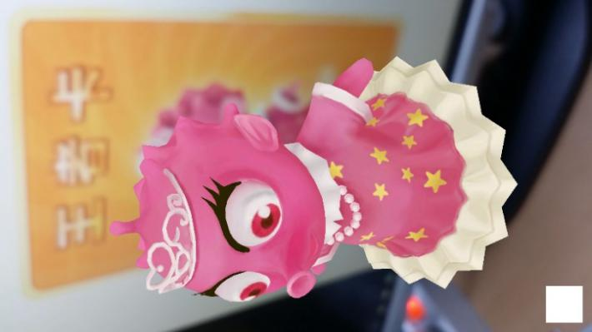 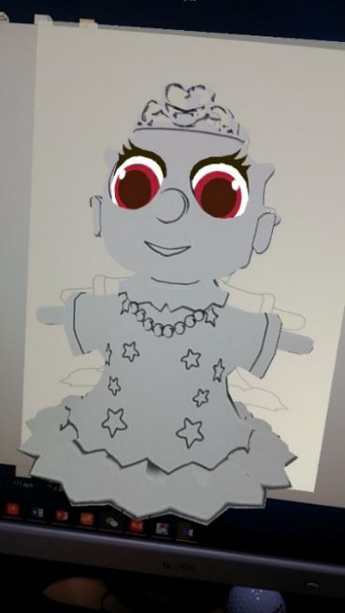

1. (b) (c)

Fig.36 The AR Scene(a)and (b); the AR+ Scene (c)

Three characters correspond to three recognition maps, and the model of each character is not static. When the three-dimensional rendering has a simple dynamic effect, when the user covers the original picture with a piece of paper with a different color, the character It will also change its color in three dimensions. The following figure is the scene of one of the characters when running: (a) Coloring the child's contrast picture; (b) Running the game with a mobile device, aiming at the picture, and displaying a 3D dynamic model at the top of the picture; (c) Using the child The other colors replace the corresponding parts of the recognition map; (d) The model displayed after the operation is changed is the model after the color change.

5.3 Project Implementation(Programing)

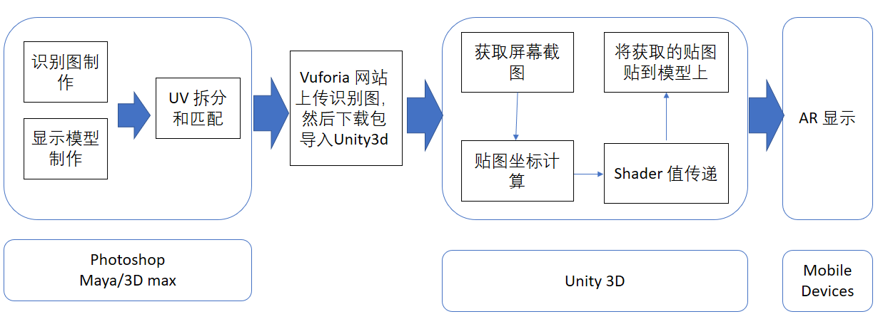

Fig.37 Application Development Steps

Get the world coordinates of the four points on the screen and save them in four variables

halfSize = new Vector2(gameObject.GetComponent<MeshFilter>().mesh.bounds.size.x,

gameObject.GetComponent<MeshFilter>().mesh.bounds.size.z) * 50.0f*0.5f;

targetAnglePoint1 = transform.parent.position + new Vector3(-halfSize.x, 0, halfSize.y);

targetAnglePoint2 = transform.parent.position + new Vector3(-halfSize.x, 0, -halfSize.y);

targetAnglePoint3 = transform.parent.position + new Vector3(halfSize.x, 0, halfSize.y);

targetAnglePoint4 = transform.parent.position + new Vector3(halfSize.x, 0, -halfSize.y);

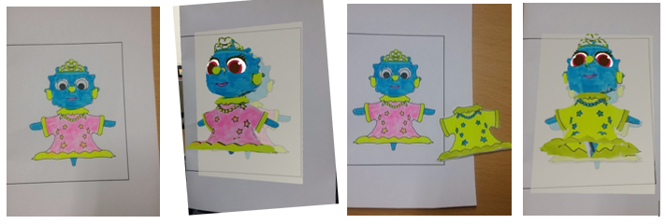

Fig.24 Corloring XiXi papers

5.4 Conclusion

The application of augmented reality technology in education has provided new ideas for teaching and learning. As a representative product, AR 3D e-book breaks through the limitations of paper books, provides learners with realistic and intuitive learning materials, and promotes knowledge. Get and absorb. "Color the Earth AR" allows the planarized object to "move on a piece of paper" through a simple and convenient scan of the mobile terminal. The interactive form stimulates the learner's interest in learning and enables them to learn knowledge and understand the world in communicating with the concept of three-dimensionality. Of course, AR 3D e-books are in the development stage. Whether it is the fidelity or interactive effect of 3D models, there are deficiencies, which need to be further improved in the later research and production. With the advancement of smart classrooms and digital learning, AR 3D e-books, as emerging learning media, will have a disruptive impact on the classroom environment, teaching model, and even education.

# **Ⅴ**. **MR Chemistry Lab**

**Limits in conventional Chemistry education**

The conventional education system modes are primarily passive or receptive learning style, many teachers think that students learned the experimental principle and method is important and enough, so they no need to do many experiments, according to our research, present teaching methods have limits shows as below: First: Lack of motivation and of activity, students are shown the experiments results instead of probing the results. Second: Temporal and spatial constraints; students cannot do the experiments anytime and anywhere for the limits of objective conditions, and cannot repeat the experiment steps. Third: Wasted reagents and danger, some of the reagents are dangerous, therefore many practices are requisite before using the real ones. In this way can save the reagents and lessen the danger. To break the limits as we build up this application, use this can let the users practice the experiments wherever and whenever they need in a more active and probing learning way, and can also can save the reagents and lessen the danger probability. Meanwhile compare to the general 2D chemistry applications it guarantees the immersion almost alike the real world, in addition we also design a feature that users can see the microcosmic things like molecular structure using mark AR. All the solutions are confirmed Improved learning efficiency.

6.1 Introduce and Design principle (Leap Motion and Oculus HMD)

The conventional education system modes are primarily passive or receptive learning style, many teachers think that students learned the experimental principle and method is important and enough, so they no need to do many experiments, according to our research, present teaching methods have limits shows as below: First: Lack of motivation and of activity, students are shown the experiments results instead of probing the results. Second: Temporal and spatial constraints; students cannot do the experiments anytime and anywhere for the limits of objective conditions, and cannot repeat the experiment steps. Third: Wasted reagents and danger, some of the reagents are dangerous, therefore many practices are requisite before using the real ones. In this way can save the reagents and lessen the danger. To break the limits as we build up this application, use this can let the users practice the experiments wherever and whenever they need in a more active and probing learning way, and can also can save the reagents and lessen the danger probability. Meanwhile compare to the 2d chemistry applications it guarantees the immersion almost alike the real world, in addition we also design a feature that users can see the microcosmic things like molecular structure using mark AR. All the solutions are confirmed Improved learning efficiency.

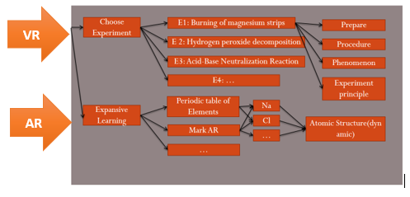

Fig.26 The User Interface

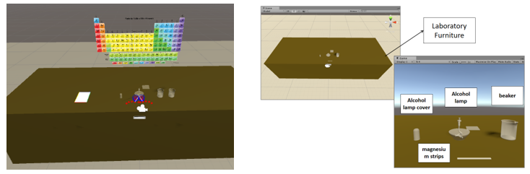

Fig.27 Game composition

**Burning of magnesium strips**

* Read the guidelines or videos on the desk (mark AR)
* Grab the match on the desk and Lighting alcohol lamp
* Put on the goggles
* Use a pair of tweezers to clip one of the two magnesium strips on the table and burn one on the alcohol lamp
* See and record the phenomenon
* Put the burned magnesium strips in a beaker containing vinegar, Put the other(unburned) magnesium strips in a beaker containing vinegar
* See and record the phenomenon
* Extinguishing alcohol lamp

**Interaction design**

We use LeapMotion as the interaction tool ,users’ hand is recognized as fig below.

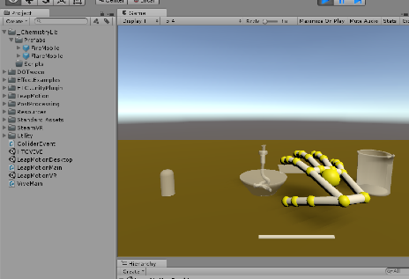

Fig.28 Hand control with Leap Motion

6.2 Project Implementation(Programing)

[Define some gesture](javascript:;)s that can interact with the object more accurate, such as lighting the alcohol lamp by pointing (with one index finger) the top of the alcohol lamp.

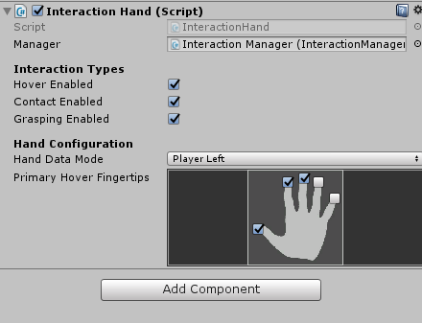 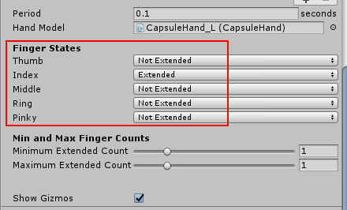

Fig. 29 [Definition of hand gesture](javascript:;)s: Lighting the alcohol lamp by pointing with the index finger

# **Ⅴ Evaluation Result**

4.1 Evaluate and Conclusion实验设计和数据分析

四个应用程序分别针对不同年龄的对象进行测试，Board Game 和 AR 3d coloring game 针对的对象是 学龄前儿童，而 VR art Show 和 VR Chemistry Lab 针对的是成人。因此我们的测试任务分为四个组进行。

4.1.1 Evaluation system

测试

1, Price-performance ratio (hardware, cost, portability…)

2, UX (diagram, interview)

3, Educational effect (questionnaire survey)

4.1.2 Evaluations for the 4 cases

4.2 Evaluation Result

4.2.1 Subjective Evaluation

4.2.2 Objective Evaluation

4.2.3 Usability Evaluation

4.2 Summary

# **Ⅴ Conclusions and Discussion**

This chapter reviews the achievements of the research objectives. Then, the

conclusions and contributions of the research are discussed. Finally, some

possibilities of future researches are outlined.

5.1 Review of Objectives

根据研究的实验结果解决之前提出的问题：

5.2 Contributions and Conclusions

5.3 Discussions

5.3.1 Limitations

“我的问题始终是：虚拟现实与教育片到底有什么不同？”教育科技博客作者及撰稿人奥黛丽·沃特斯（Audrey Watters）说道，“我确实担心，人们会越来越多地在模拟或虚拟现实技术的伪装下使用教育片代替学生的外出实地考察以及其他线下的丰富活动。”[2]

5.4 Recommendations for future work

Future directions in Augment and Virtual reality ---expanding applications ---Apply AR/VR mode in Other subjects (Match, physics, art, biology, geography…)

Appendix I: Virtual & Augmented Education Scenarios

Appendix II: Questionnaire for Subjective Evaluation

Appendix III: Paper Based Examination

Appendix IV: Comparison of use of VR and AR system with traditional whiteboard based lecture

References

1. AR, http://whatis.techtarget.com/definition/augmented-reality-AR, [Article(CrossRef Link)](http://whatis.techtarget.com/definition/augmented-reality-AR)

——http://www.baike.com/wiki/ugc?hf=youdaocitiao&pf=youdaocitiao

1. <http://vr.99.com/news/07192017/001616650.shtml>
2. 作者：胡痴儿2.0。链接：https://www.zhihu.com/question/36979454/answer/95047656
3. 作者：犬一。链接：https://www.zhihu.com/question/36979454/answer/125991422
4. 作者：世界两侧。链接：<https://www.zhihu.com/question/36979454/answer/90834848>
5. 作者：陈儿.链接：<https://www.zhihu.com/question/36979454/answer/191543111>
6. <https://www.quora.com/What-is-the-difference-between-augmented-reality-and-mediated-reality-1>
7. <http://jp.trane.com/commercial/global/latin-america/es/markets/k-12-education.html>
8. <https://zhuanlan.zhihu.com/p/22135486>
9. The Virtual Lab (Physics & Chemistry) for Malaysia’s Secondary School [accessed Oct 3, 2017].
10. Augmented Reality: What Does It Mean for UX?
11. <http://www.weihk.cn/article/237816>
12. Google Translate review: how well does the new app work?
13. WU H K,LEE S W Y,CHANG H Y,et al.Current Sta-tus,Opportunities and Challenges of Augmented Reality in Education[J].Computers & Education(S0360-1315),2013,62(3)： 41-49.
14. The Economics.The Promise of Augmented Reality[DB/OL]. (2017-02-04)[2017-02-28].http://www.economist.com/news/ science-and-technology/21716013-replacing-real-world-virtual-one-neat-trick-combining-two.
15. NUNEZ M,QUIROS R,NUNEZ I,et al.Collaborative Aug-mented Reality for Inorganic Chemistry Education In 5th WSEAS/IASME International Conference on Engincering Education,Heraklion,Greece,July 22-24,2008.
16. GOLDMAN SACHS.Virtual & Augmented Reality Under-standing the Race for the Next Computing Platform[DB/OL]. (2016-03-09)[2017-02-20].http://www.goldmansachs.com/ our-thinking/pages/virtual-and-augmented-reality-report.html.
17. WATSON J B.Psychology as the Behaviorist Views It[J].Psy-chological Review(S0033-295X),1913,20(2)：158.
18. PIAGET J.The Stages of the Intellectual Development of the Child.Educational Psychology in Context:Readings for Future Teachers [M].1965.
19. JONASSEN D H.Thinking Technology:Toward a Construct-ivist Design Model[J].Educational Technology(S0013-1962), 1994,34(4)：34-37.
20. 蔡苏, 王沛文, 杨阳, 等. 增强现实(AR) 技术的教育应用综述 [J]. 远程教育杂志,2016,(5)：27-40.
21. RYFFEL M,MAGNENAT S.Augmented Creativity: Bridging the Real and Virtual Worlds to Enhance Creative Play[C].Proceedings of the SIGGRAPH Asia 2015 Mobile Graphics and Interactive Applications,Kobe:ACM，2015：1-12.
22. HORNECKER E,DUNSER A.Of Pages and Paddles: Children’s Expectations and Mistaken Interactions with Physical-digital Tools [J].Interacting with Computers (S0953-5438),2009,21(1)：95-107.
23. Virtual &Augmented Reality The Goldman Schs Group,Inc. Jan 13,2016.
24. <https://zhuanlan.zhihu.com/p/32865565>
25. Human interface guidelines <https://developer.apple.com/ios/human-interface-guidelines/technologies/augmented-reality/>
26. Thomas Caudell and David Mizell Augmented reality: An application of heads-up display technology to manual manufacturing processes
27. 王丹，段渭军，李星，SOOLDE在工科院校实验合成中应用初探，现代教育技术Modern Educational Technology， Vol.20, No, 12, 2010
28. <http://www.shafa.com/articles/zIHzY7BRArZmpcYY.html>
29. <https://t.qianzhan.com/kuaixun/detail/161118-3fa346e7.html>
30. iPhone X’s Emoji Innovation Tracks Your Face
31. AR, http://whatis.techtarget.com/definition/augmented-reality-AR, [Article(CrossRef Link)](http://whatis.techtarget.com/definition/augmented-reality-AR)